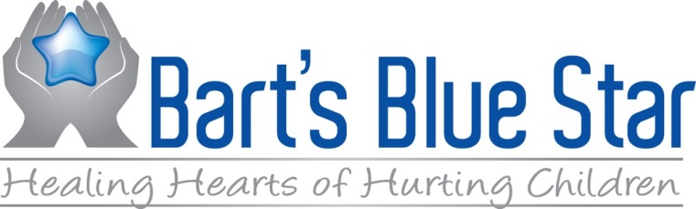

Grant Funding Guidelines
- The grant process will be open during a stated period of time during the calendar year and will be announced via website and other appropriate vehicles.
(Current timing: February 15-April 15: Grants accepted; June: Grants announced.)
- Grant applications are open to 501(c)(3) organizations and other qualified nonprofit organizations in the Treasure Coast (Indian River, St. Lucie, Martin and Okeechobee) area as well as North Palm Beach County.
- MINIMUM available grant funding will be determined by the Board at the recommendation of the Treasurer at the end of each fiscal year. The formula will be 5% of the balance of funds available in the Foundation accounts.
- Maximum funding for each grant application is 50% of the budgeted costs of training and instructional materials; travel is not covered by grant funding.
- A Review Committee will be appointed by the Board each year to review grant applications. Application reviews should be completed no later than one month after the application deadline.
- A letter will be sent to each grant applicant with the decisions of the Review Committee. If an applicant receives funding, a letter outlining the follow up procedures will be attached.
- The Review Committee will review all funded grants follow up documents once a year.

